BRACT’s
Vishwakarma Institute of Technology, Pune

Department: CSE-AI Semester: 5 Academic Year: 2026-27
Division: E Batch: 3 Practical No: 4
Roll no: 71 PRN No: 12415150 Name: RAJ SONUNE
Subject Name : Deep Learning

1. Objective
To develop an LSTM-based deep learning model for time-series forecasting and predict future stock prices using historical stock-price data.
2. Dataset
The dataset contains daily stock-price values for five stocks (Stock_1 to Stock_5). For this experiment, Stock_1 is selected for prediction.
3. Algorithm
- Load the stock-price dataset.
- Convert the date column into the required date format.
- Select Stock_1 as the target variable.
- Normalize the stock-price values using Min-Max Scaling.
- Create sequences using the previous 30 days of stock prices.
- Split the data into training and testing sets.
- Reshape the data into the format required by the LSTM model.
- Build an LSTM model with LSTM, Dropout, and Dense layers.
- Compile the model using the Adam optimizer and Mean Squared Error (MSE) loss function.
- Train the model using the training data.
- Predict stock prices using the test data.
- Calculate MAE and RMSE to evaluate the model.
- Plot the actual and predicted stock prices.
4. Model Architecture
Input Sequence (30 Days)
↓
LSTM Layer (50 neurons)
↓
Dropout (20%)
↓
LSTM Layer (50 neurons)
↓
Dropout (20%)
↓
Dense Layer
↓
Predicted Stock Price

5. Parameters Used
Parameter | Value
Sequence Length | 30 days
Training Data | 80%
Testing Data | 20%
LSTM Units | 50
Dropout | 0.2
Optimizer | Adam
Loss Function | Mean Squared Error
Epochs | 20
Batch Size | 16
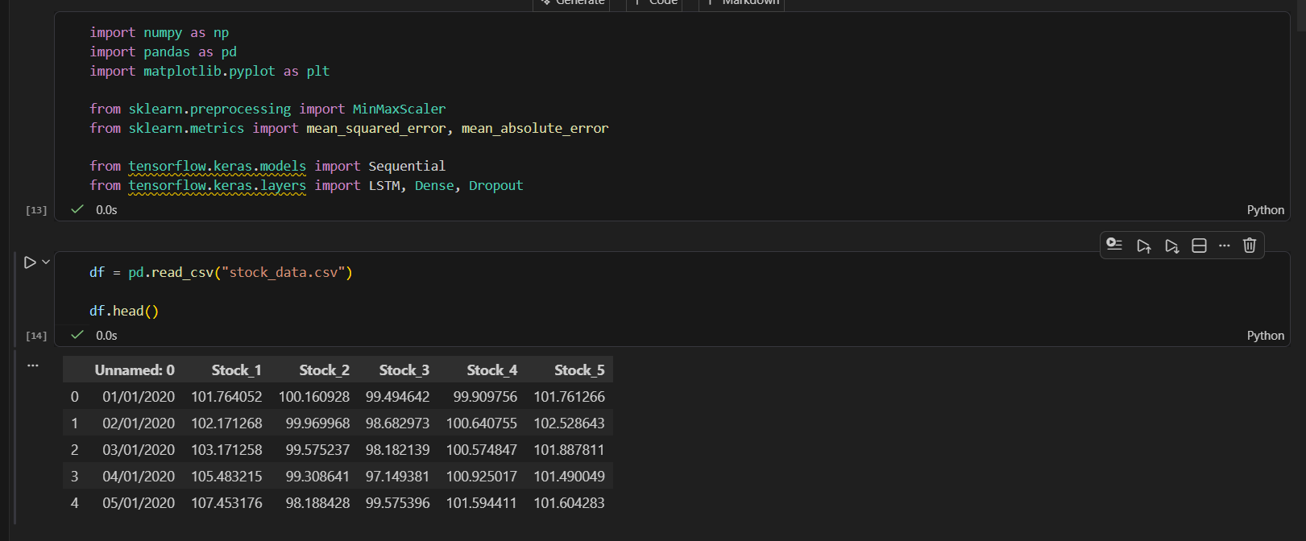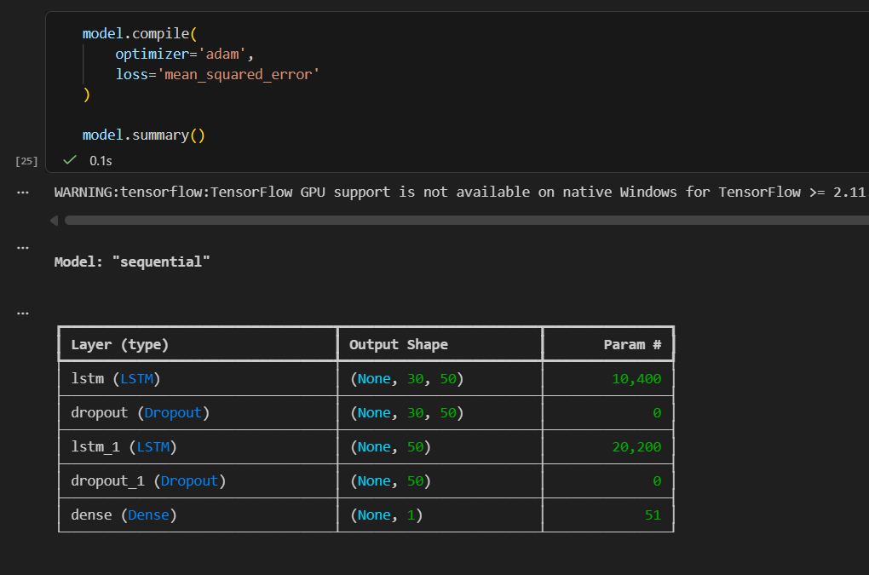
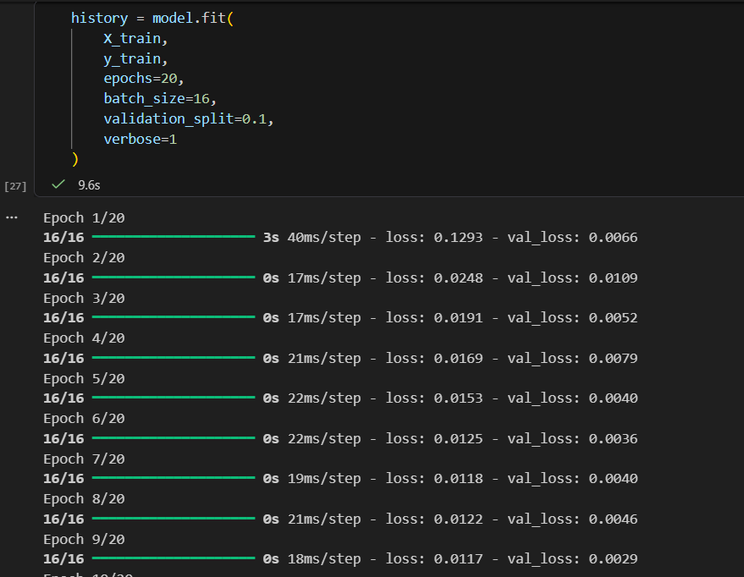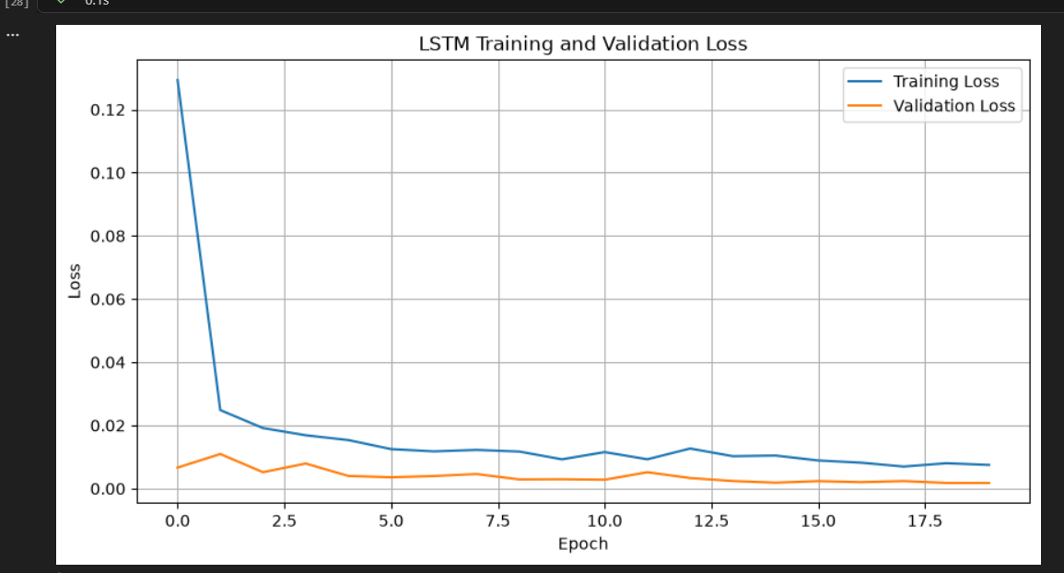

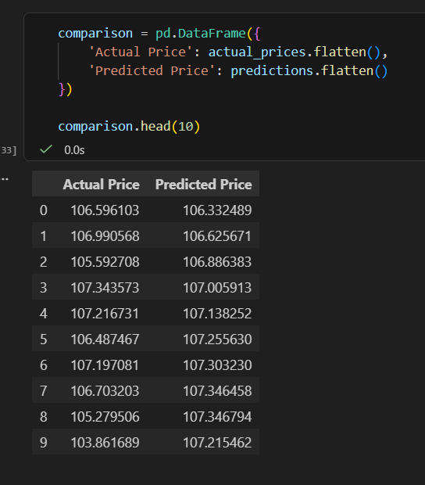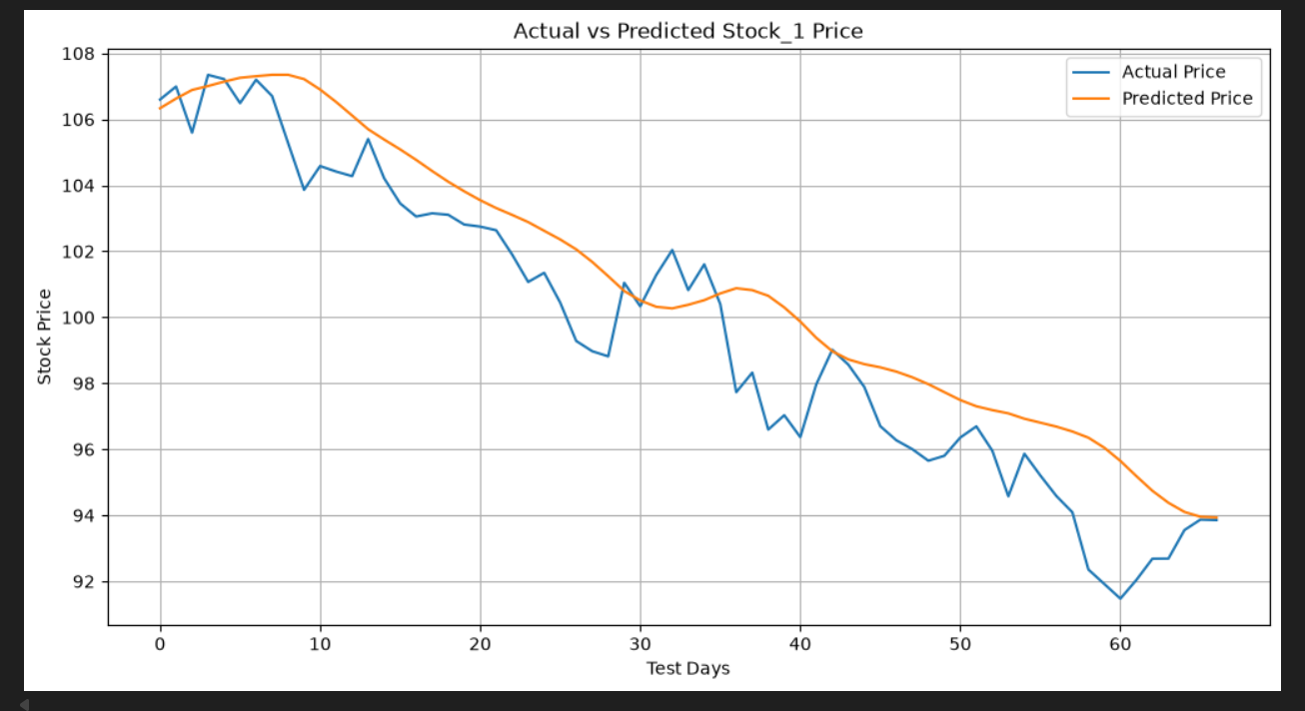

6. Evaluation Metrics
MAE (Mean Absolute Error): Measures the average absolute difference between actual and predicted prices.
RMSE (Root Mean Squared Error): Measures prediction error and gives more importance to larger errors.
Lower values of MAE and RMSE indicate better model performance.
7. Result
The LSTM model was trained successfully on the historical stock-price data. The model generated predicted stock prices, which were compared with the actual stock prices using numerical evaluation metrics and an Actual vs Predicted graph.
8. Conclusion
The LSTM model can learn patterns from historical time-series data and use previous stock prices to predict future prices. The experiment demonstrates that LSTM is suitable for time-series forecasting because it can retain information from previous time steps.

